Sponsor & Exhibitor Invitation
NASW/CT’s 31st Annual Conference
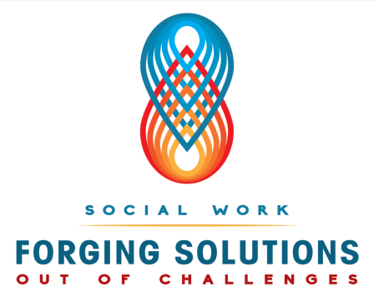
May 6, 2016

Radisson Cromwell (formerly the Crowne Plaza), Cromwell, CT

Yes, we would like to join you for this occasion.
Please sign us up!

Organization:________________________________________________
Address:____________________________________________________ ____________________________________________________________
Contact Person:______________________________________________
Phone Number:______________________________________________
Fax Number:________________________________________________
E-Mail Address:______________________________________________

- PARTNERING SPONSOR $ 3000
- BROCHURE SPONSOR (deadline 2/12/16) $ 1500
- TOTE BAG SPONSOR (deadline 4/8/16) $ 1000
- Keynote Speaker Sponsor $ 750
- Lunch Sponsor $ 500
- Exhibit Table $ 400
• Coffee Break $ 300
• Workshop Sponsor $ 150
• Packet Sponsor (deadline 5/2//16) $ 75

Please make checks payable to: National Association of Social Workers, CT Chapter,
2139 Silas Deane Highway, Ste. 205, Rocky Hill, CT 06067

