Sponsor & Exhibitor Invitation
NASW/CT’s 32nd Annual Conference
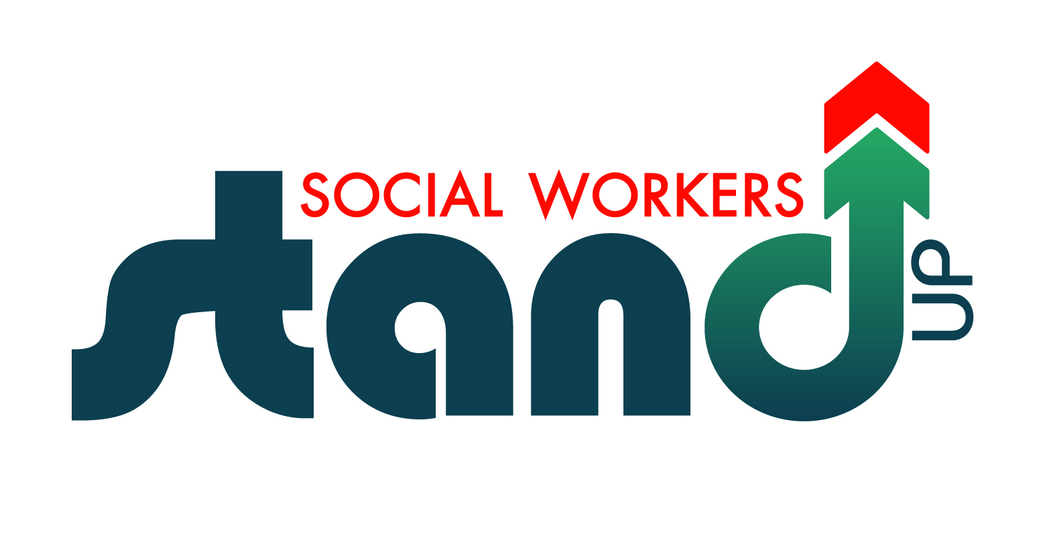
May 12, 2017

Radisson Cromwell, Cromwell, CT

Yes, we would like to join you for this occasion.
Please sign us up!

Organization:________________________________________________
Address:____________________________________________________ ___________________________________________________________
Contact Person:______________________________________________
Phone Number:______________________________________________
Fax Number:________________________________________________
E-Mail Address:______________________________________________

- PARTNERING SPONSOR $ 3000
- TOTE BAG SPONSOR (deadline 4/10/17) $ 1500
- BROCHURE SPONSOR (deadline 2/13/17) $ 1000
- Keynote Speaker Sponsor $ 750
- Lunch Sponsor $ 550
- Exhibit Table $ 450
• Breakfast Sponsor $ 350
• Workshop Sponsor $ 150
• Packet Sponsor (deadline 5/8/17) $ 75

Please make checks payable to: National Association of Social Workers, CT Chapter,
2139 Silas Deane Highway, Ste. 205, Rocky Hill, CT 06067.
Please call the office 860 257-8066 to pay by credit card.

