NASW/CT’s 34th Annual Conference

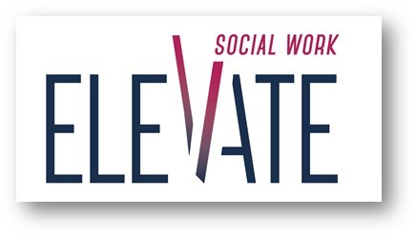

May 3, 2019

Red Lion Hotel, Cromwell, CT

### Conference Brochure Ad Form

**Organization:**

**Contact Person: Phone Number:**

**Address:**

**City: State: Zip:**

#### Advertising Rates

# Type of Ad Size Fee

** Business Card Display Ad 3 ½ x 2 $90.00**

** ¼ Page Display Ad 3 ½ x 4 ¾ $195.00**

** ½ Page Display Ad 7 ¼ x 4 ¾ $275.00**

** Full Page Display Ad 7 ¼ x 9 ¾ $400.00**

**Please mail form and BLACK AND WHITE camera ready artwork—in JPEG please-- to:**

NASW/CT Conference Brochure Book

2139 Silas Deane Hwy., Suite 205

Rocky Hill, CT 06067

**Email your ad to:** [**info.naswct@socialworkers.org**](mailto:info.naswct@socialworkers.org) **by February 15, 2019**

For questions please call 860-257-8066 or email us at [info.naswct@socialworkers.org](mailto:info.naswct@socialworkers.org)

**Our conference brochure will be distributed to over 3000 Social Workers!**