Sponsor & Exhibitor Invitation
NASW/CT’s 35th Annual Conference
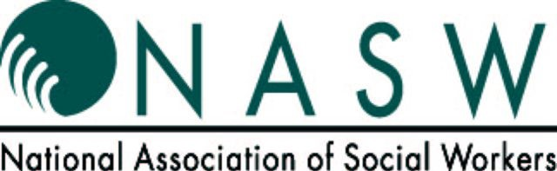
May 8, 2020

Red Lion Hotel, Cromwell, CT
Yes, we would like to join you for this occasion.
Please sign us up!

Organization:________________________________________________
___________________________________________________________
Address:____________________________________________________ ___________________________________________________________
Contact Person:______________________________________________
Phone Number:______________________________________________
Fax Number:________________________________________________
E-Mail Address:______________________________________________

- PARTNERING SPONSOR $ 3000
- TOTE BAG SPONSOR (deadline 4/10/20) $ 1500
- BROCHURE SPONSOR (deadline 2/14/20) $ 1000
- Keynote Speaker Sponsor $ 750
- Lunch Sponsor $ 550
- Exhibit Table $ 450
- Wine & Cheese Reception Sponsor $ 350
• Breakfast Sponsor $ 350
• Workshop Sponsor $ 150
• Packet Sponsor (deadline 4/27/20) $ 75

Please make checks payable to: National Association of Social Workers, CT Chapter,
2139 Silas Deane Highway, Ste. 205, Rocky Hill, CT 06067.
OR call the office (860) 257-8066 to pay by credit card or pay online at www.naswct.org

