# **Sponsor & Exhibitor Invitation**

NASW/CT’s 35th Annual Conference  
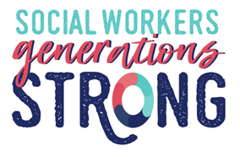  
**May 29, 2020**

Mystic Marriott, Groton, CT

*Yes, we would like to join you for this occasion.*

*Please sign us up!*

Organization:________________________________________________

___________________________________________________________

Address:____________________________________________________ ___________________________________________________________

Contact Person:______________________________________________

Phone Number:______________________________________________

Fax Number:________________________________________________

E-Mail Address:______________________________________________

* **PARTNERING SPONSOR $ SOLD OUT**
* **TOTE BAG SPONSOR (deadline 4/10/20) $ SOLD OUT**
* **BROCHURE SPONSOR (deadline 2/14/20)** **$ 1000 (front cover)**
* **BROCHURE SPONSOR (deadline 2/14/20**) **$ 900 (back cover)**
* **Keynote Speaker Sponsor $ 800**
* **Lunch Sponsor $ 600**
* **Exhibit Table $ 450**
* **Wine & Cheese Reception Sponsor $ 350**

**• Breakfast Sponsor $ 350**

**• Workshop Sponsor $ 250**

**• Packet Sponsor (deadline 4/27/20) $ 99**

Please make checks payable to: National Association of Social Workers, CT Chapter,   
2139 Silas Deane Highway, Ste. 205, Rocky Hill, CT 06067.  
 OR call the office (860) 257-8066 to pay by credit card or pay online at [www.naswct.org](http://www.naswct.org)