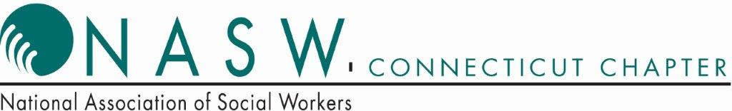
NASW/CT 34th Annual Statewide Conference
May 3, 2019
Radisson Cromwell, Cromwell, CT

Call For Proposals

NASW/CT is now accepting papers for its 34th Annual Statewide Conference
to be held on May 3, 2019 at the Radisson Cromwell Hotel in Cromwell, CT.
In this unique profession of ours, we strive to help people in all stages and walks of life. The professional social worker needs to acquire knowledge in numerous arenas including prevention, treatment, direct service, private practice, social policy,
cultural competency, administration, community organization, and legislation.
The conference committee is seeking proposals that explore topics in varying fields of social work practice and at all levels (micro, mezzo, or macro).
The workshop presentations should appeal to experienced social workers
and others in allied fields.

Guidelines for Proposals

The committee recommends that one of the presenters has a BSW or MSW degree
or be a social work student but this is not required for a proposal to be accepted.
To make the presentation informative and rewarding for the Conference audience, the committee suggests that presenters plan to address their remarks to professionals with intermediate or advanced levels of experience and knowledge. Social Workers appreciate specific “how to” comments and relevant examples. Please do not plan to read a power point or only lecture as our participants prefer interactive programs.

Submit a copy of the Proposal which includes a description of your professional experience, the Abstract, and the Brief Summary Abstract by December 10, 2018. We request that you include your objectives in the Abstract as well as a few sentences regarding how the presentation incorporates social work values.
NOTE: No Personal Identification should appear in the Abstract
to provide anonymity in the decision making process.
The Proposal form can be obtained from the NASW office
or the form can be down loaded from the website at www.naswct.org
Presenters attend the Annual Conference at no charge but they are asked to pay
$40 if they are joining us for lunch.
No additional presenters may be added after the Proposal is accepted. We ask that you limit your presenters to 5 should you be planning a panel.
Conference Committee decisions and notifications will be sent mid-January 2019.

Send Proposals to NASW/CT Annual Conference Committee
2139 Silas Deane Highway, Suite 205, Rocky Hill, CT 06067
Or Fax to (860)257-8074 or Email to phartman.naswct@socialworkers.org
Any questions, please call Pat Hartman at (860) 257-8066

